**7- Day Free Masterclass**

**Ethnus**

**Building a Face detection App on AWS**

**Email:** [lahari.kethinedi@gmail.com](mailto:lahari.kethinedi@gmail.com)

Name: Lahari Kethinedi

**AWS login screen**

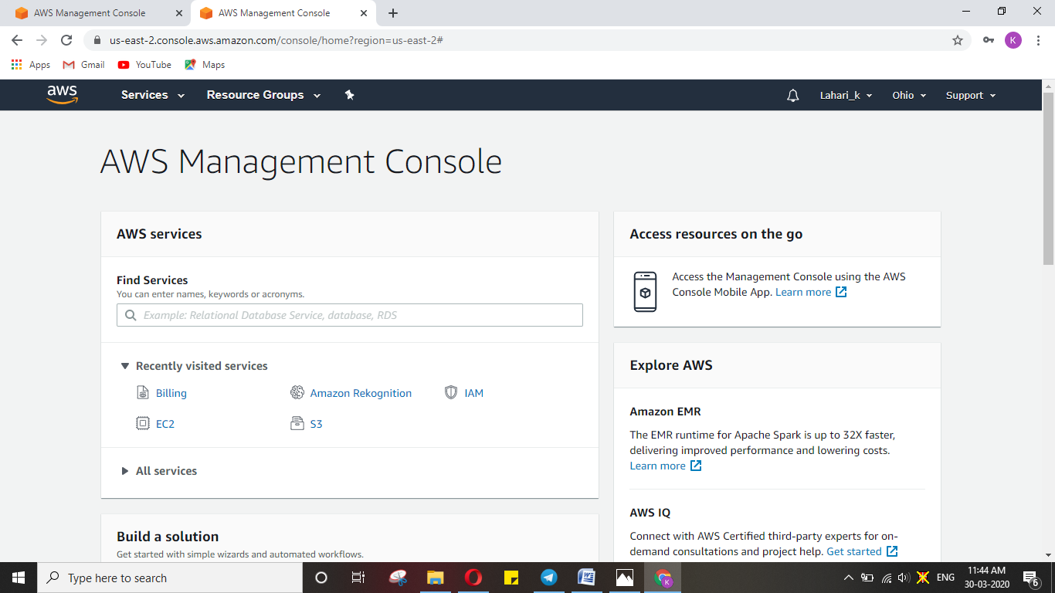

**EC2 dashboard**

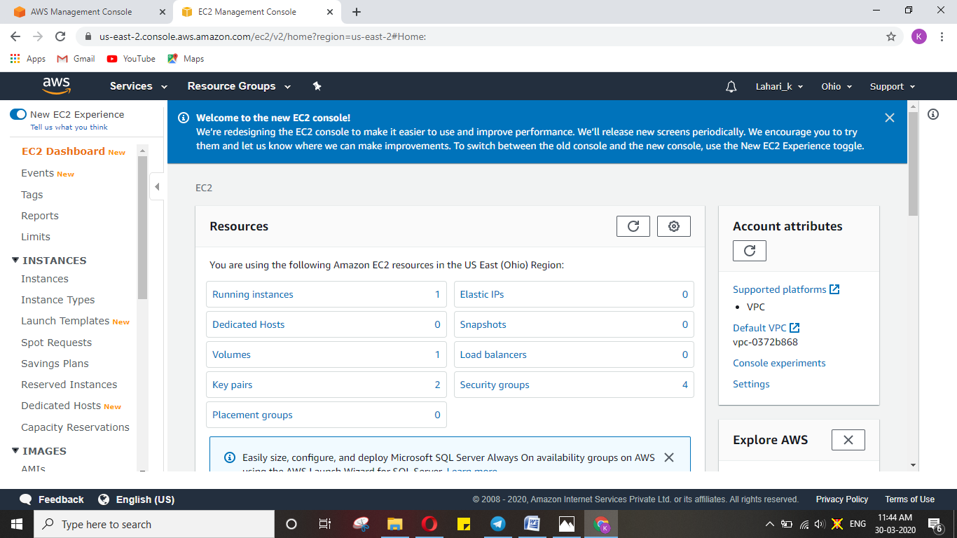

**S3 dashboard**

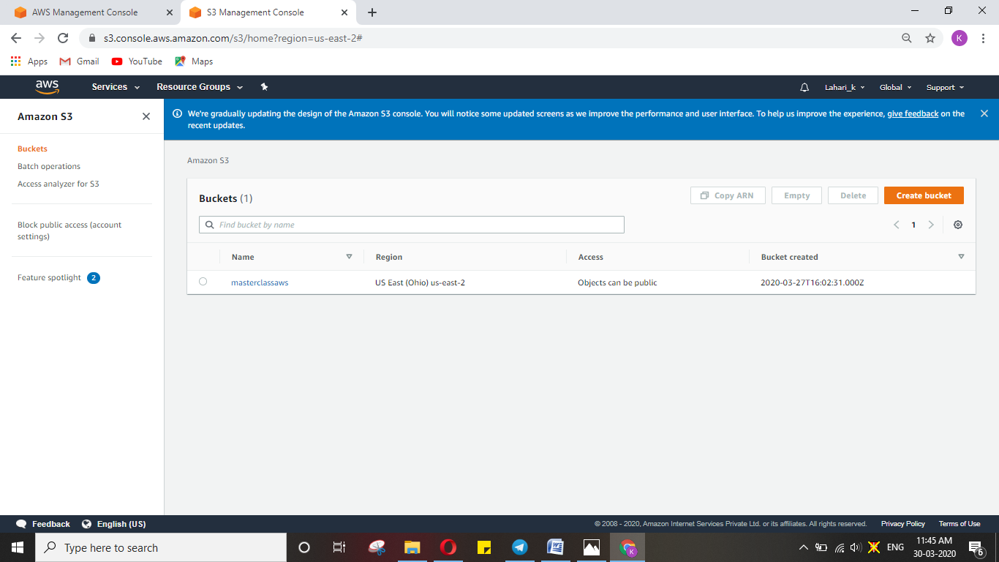

**Rekognition dashboard**

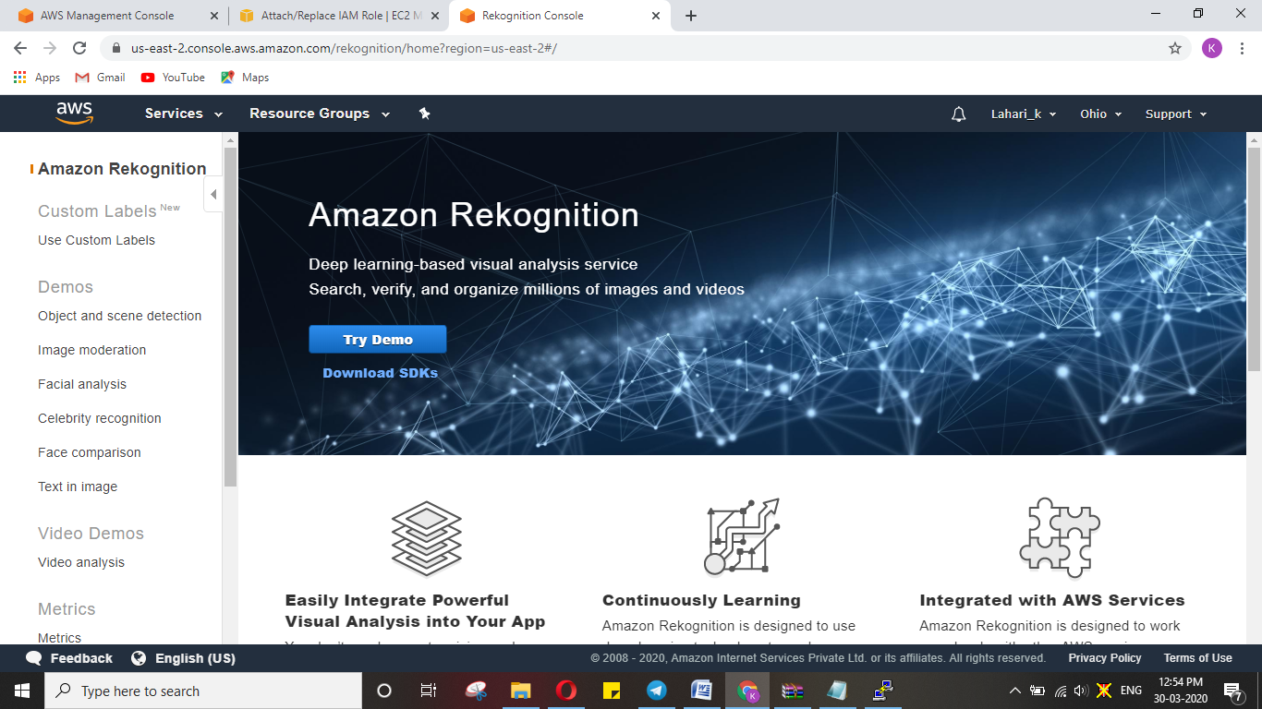

**The four major Services required for the app are:**

1. Telegram bot
2. EC2 – Elastic cloud Computing -----Virtual Computer
3. S3 –Simple Storage Device
4. Rekognition of AWS

**The basic architecture of the app and the steps involved are:**

1. Accept the image using Telegram bot.
2. Store the image using S3
3. To invoke the rekognition.
4. To take the image from S3
5. To send the facial features from rekognition back to EC2
6. To send the entire response t telegram bot

This is how the app works internally

**EC2- Elastic cloud Computing**

1. Selecting OS for the Virtual Machine --- Select Amazon Linux 2 AMI which is a free tier eligible service.

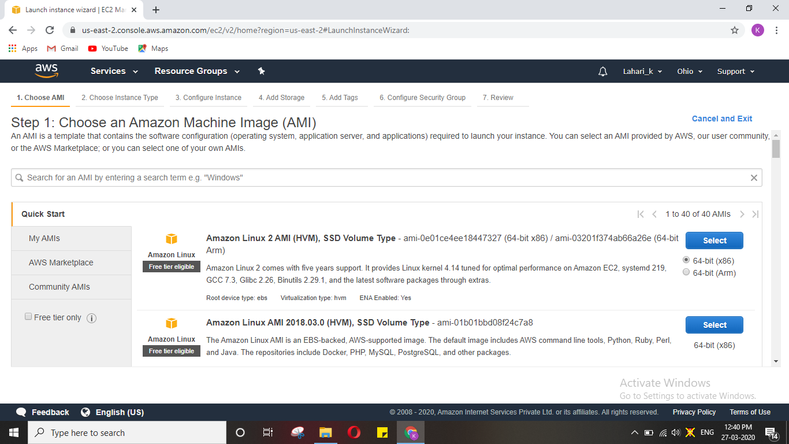

1. Configuring CPU and RAM ---one CPU of t2 type with 1GB RAM, which is also free tier

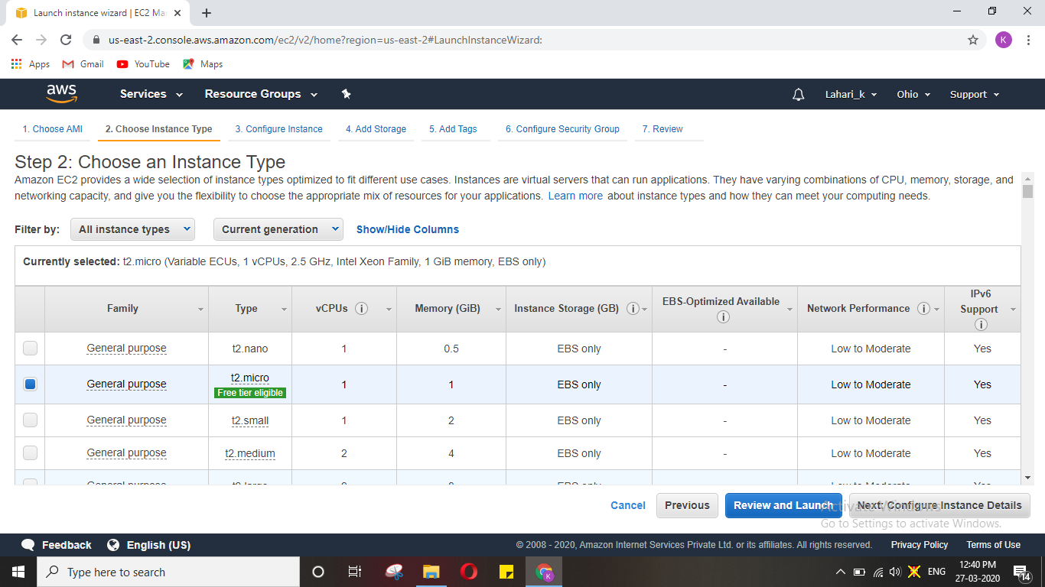

1. Configuring the Hard-disk. SSD for optimised performance with 8GB hard-disk memory

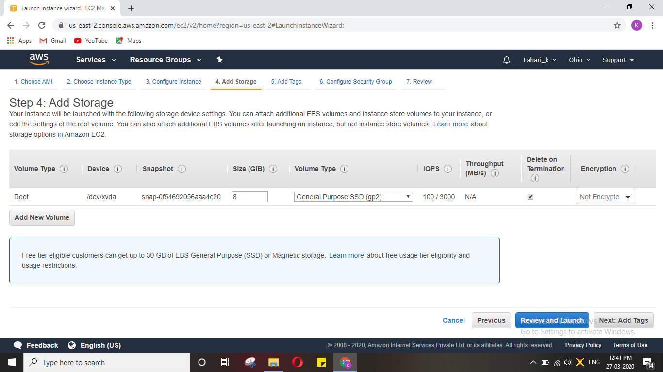

1. Configuring security to our machine --- remember the port 22 and of SSH type.

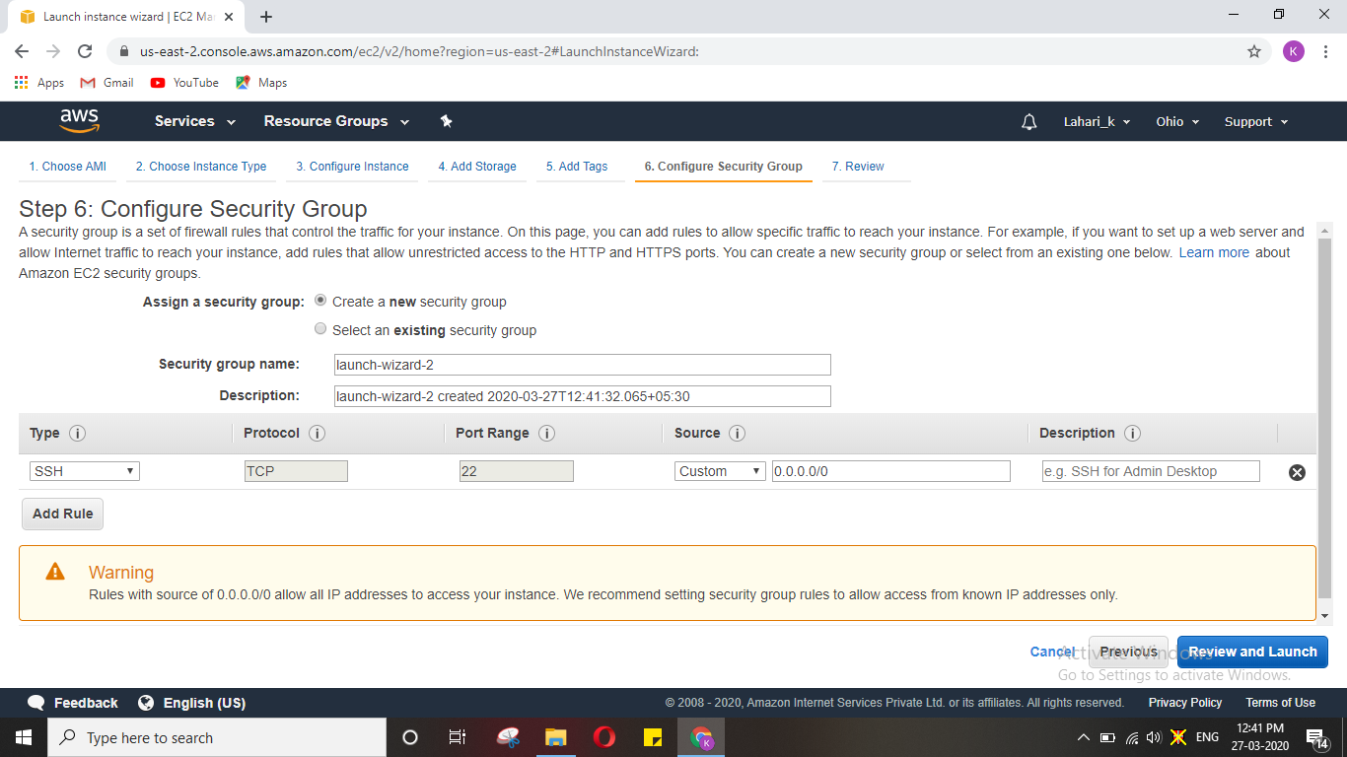

1. Create a new pair key and download it before launching.

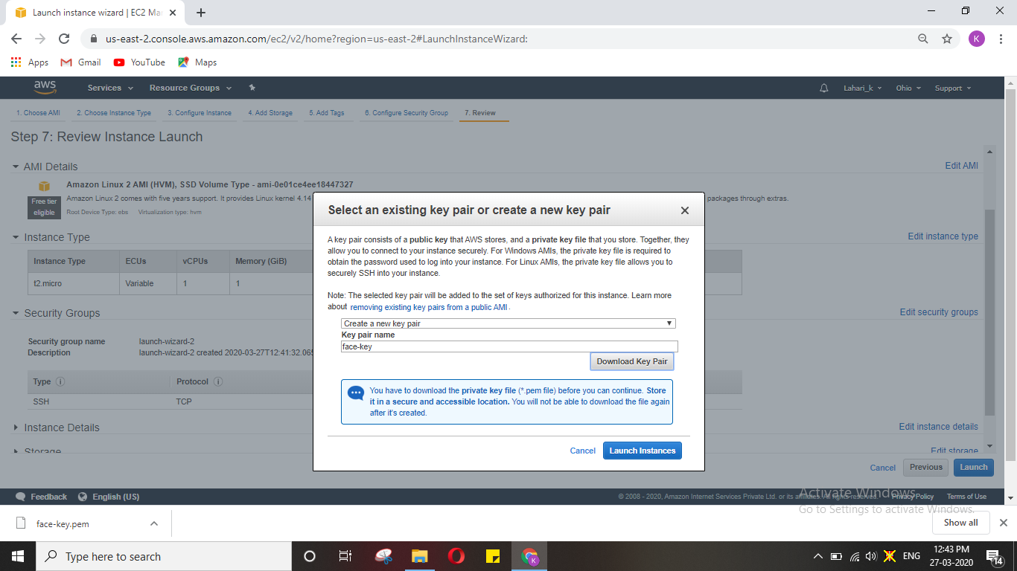

So now our instance is ready. We need to connect to this instance that is in Ohio, which can be done with the help of the key downloaded and the software putty remotely. The key downloaded is in the format .PEM. Convert the downloaded .PEM format pair key file to .PPK format using puttygen.

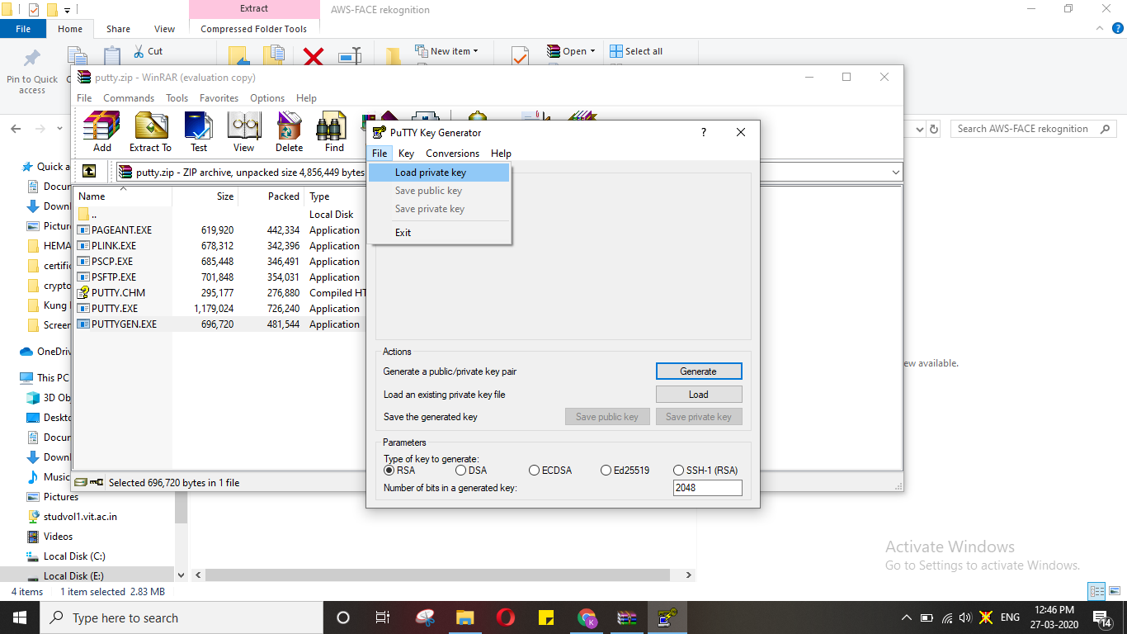

Once converted upload it in putty (as putty accepts only .ppk format).

Logged in EC2 screen

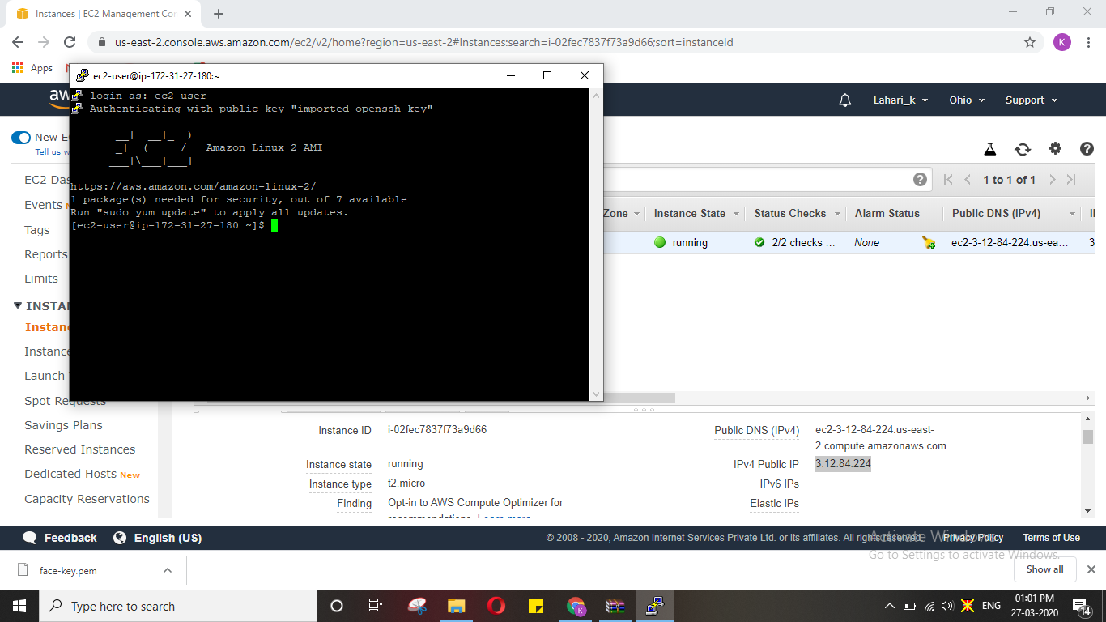

**S3- Simple Storage service**

1. Creating a Bucket.

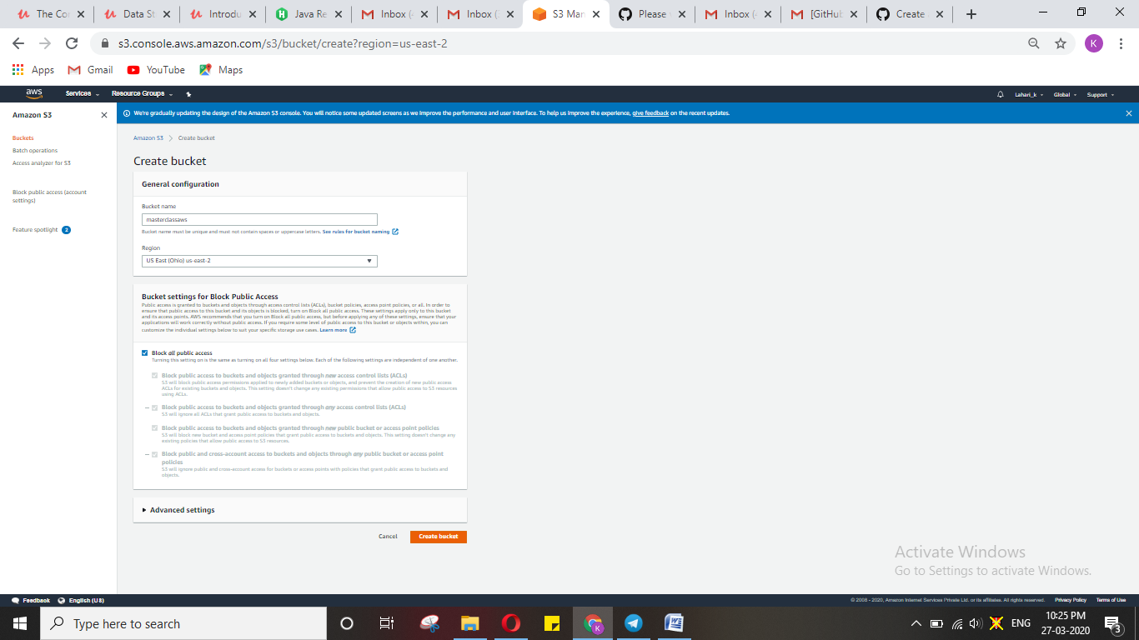

1. Uploading an Object.

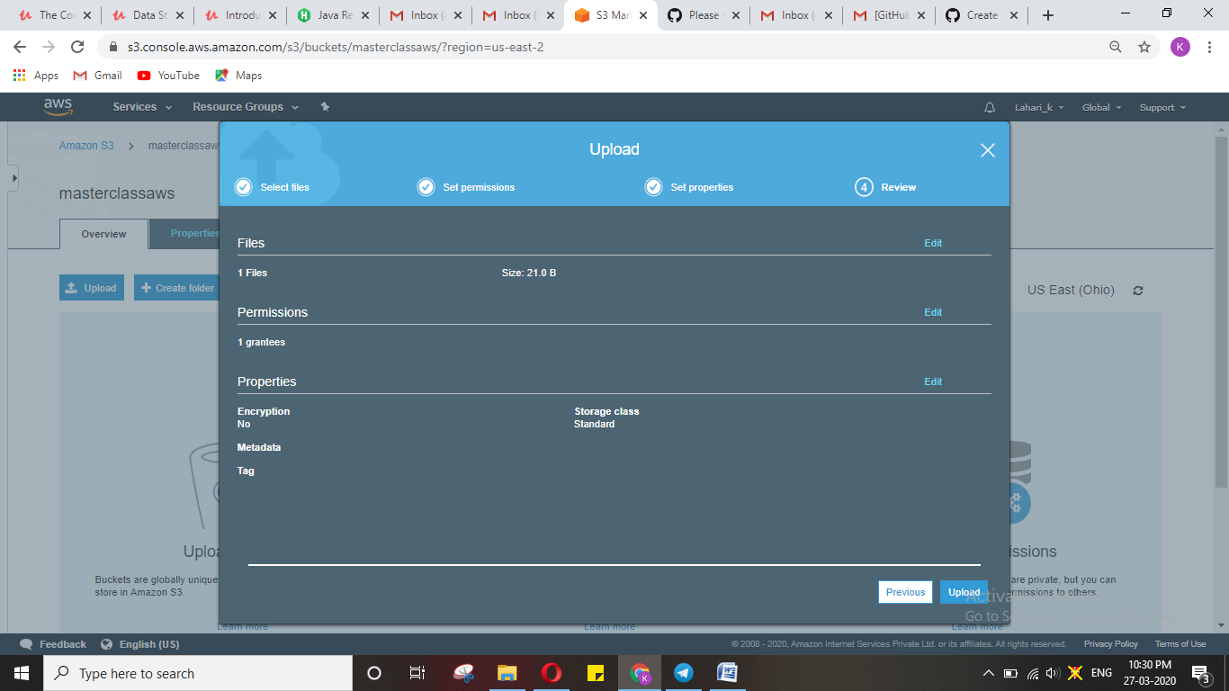

1. Enabling static website.

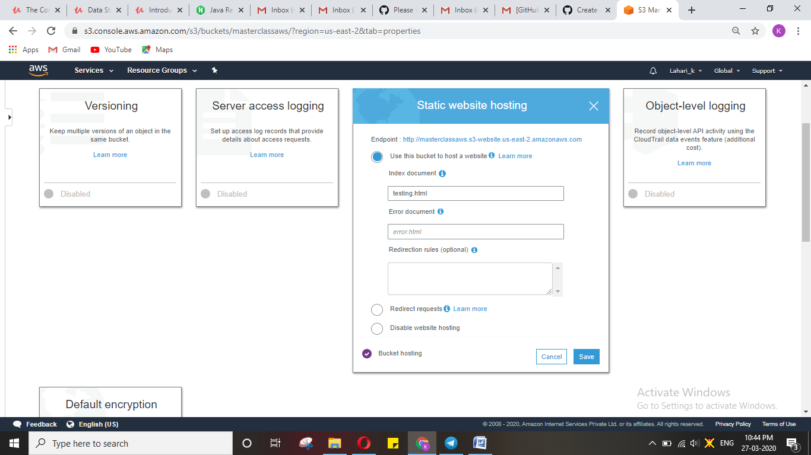

1. Making the object public.

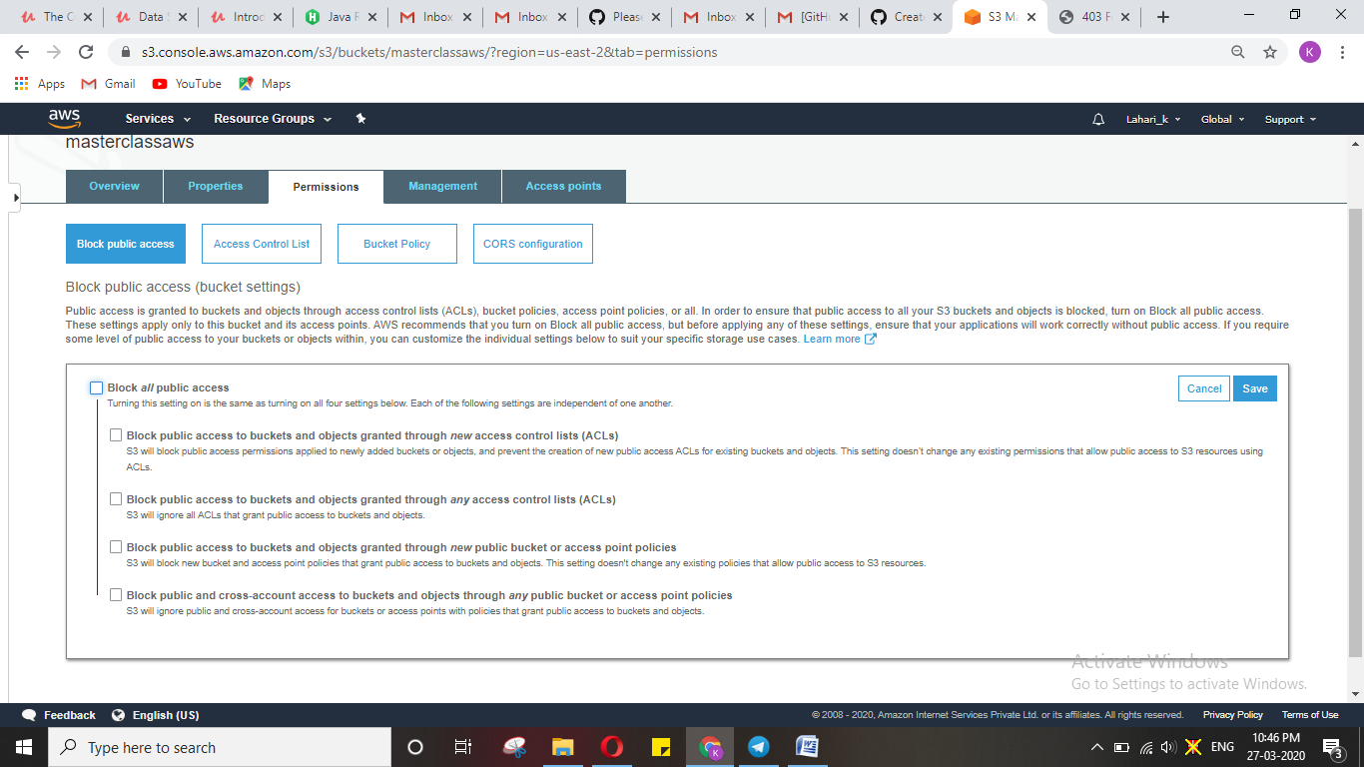

1. Checking S3 link in the browser.

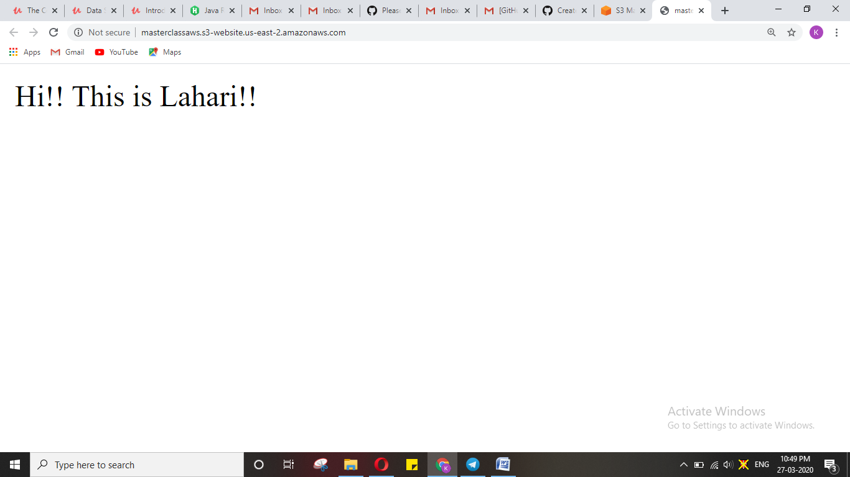

**Rekognition:**

1. Face Detect

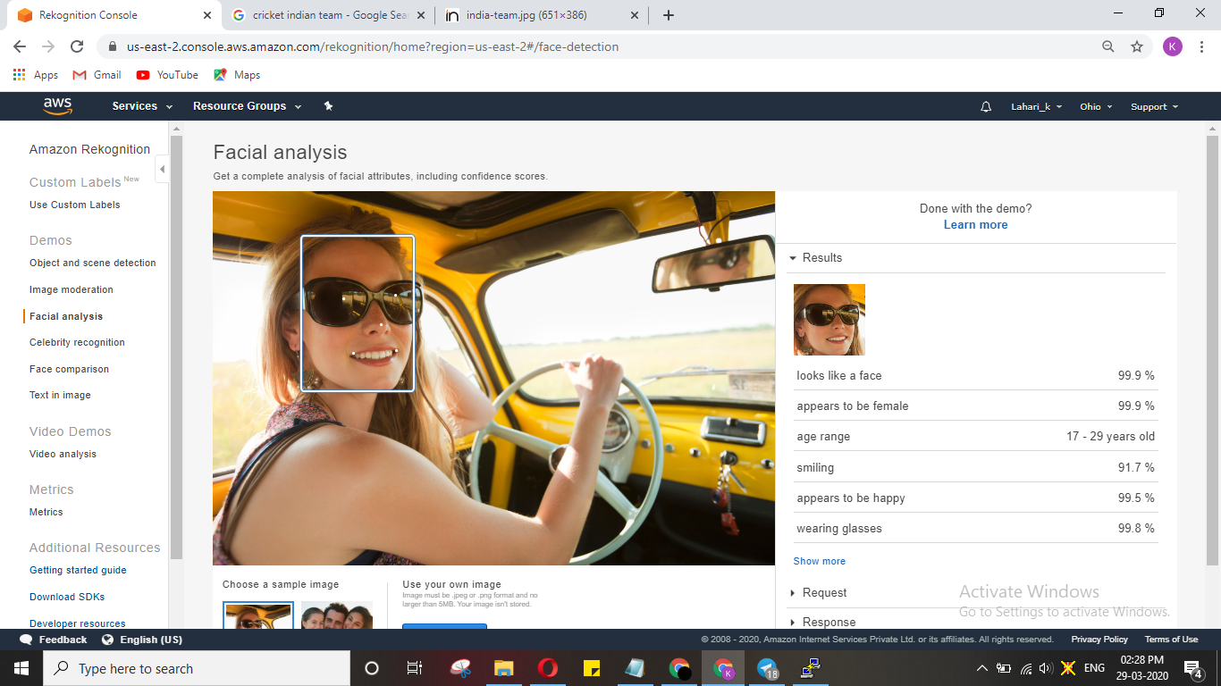

1. Face Compare

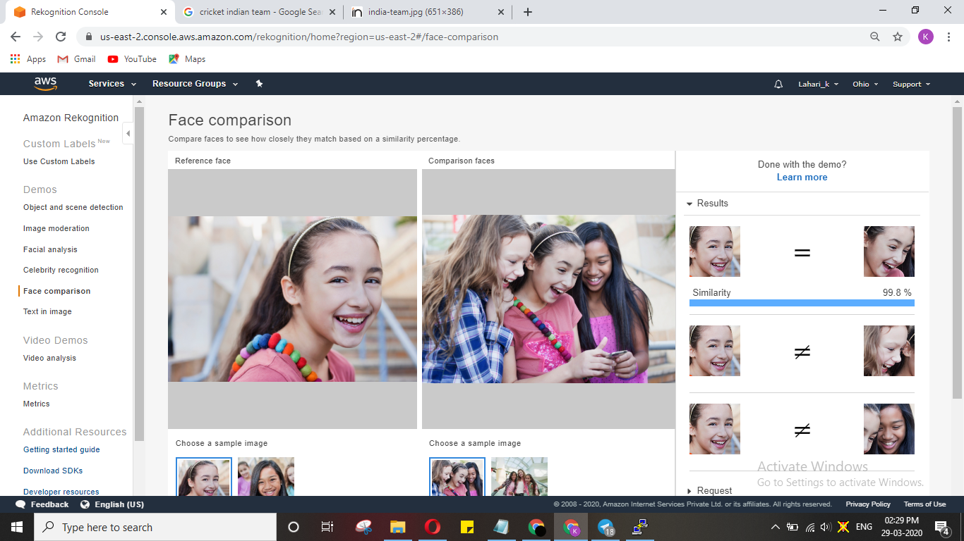

1. Celebrity recognition

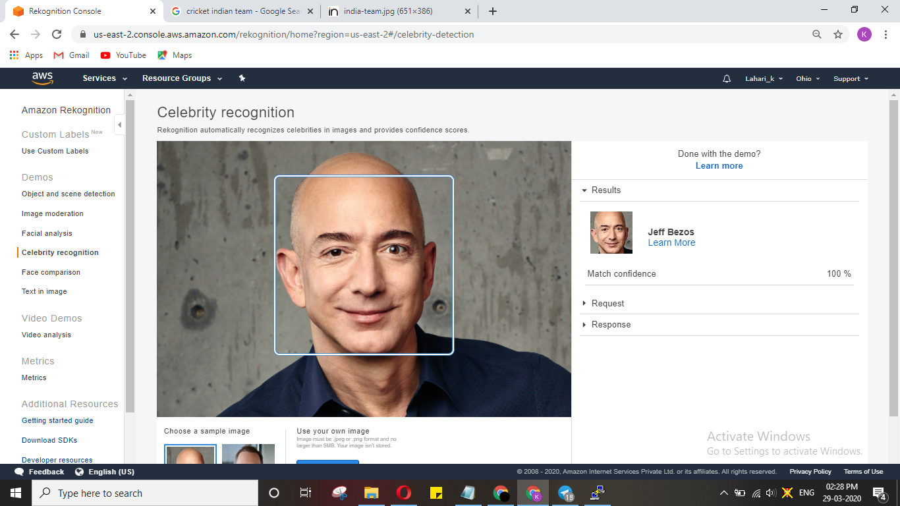

1. Text in image

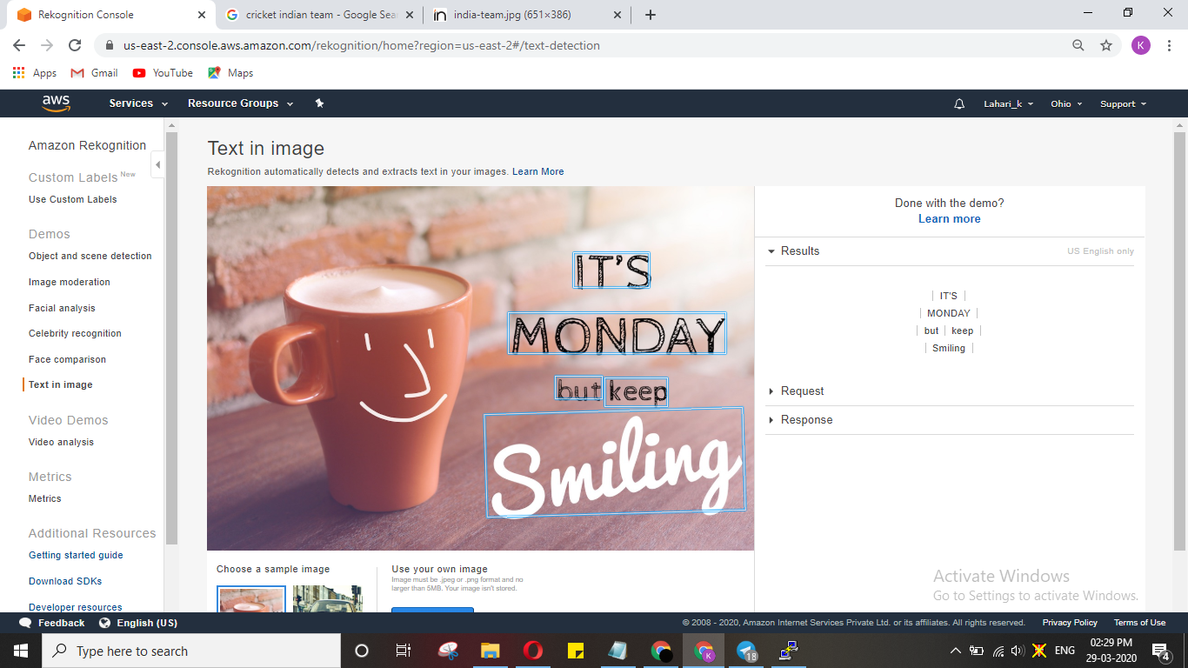

**EC2- S3**

1. Installing AWS-SDK

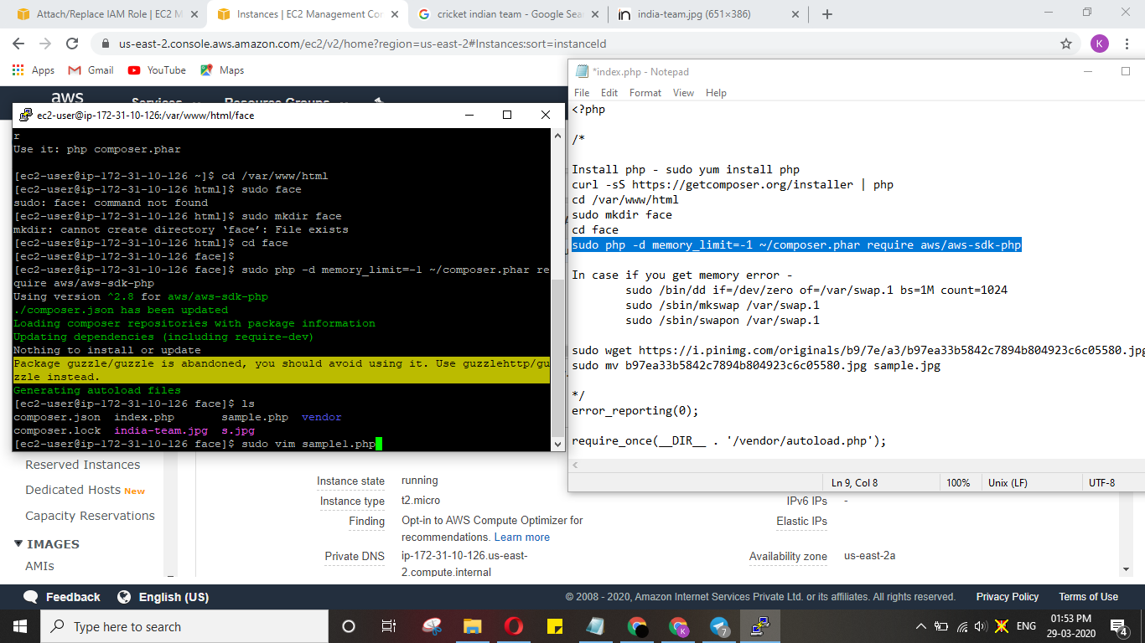

1. Installing PHP

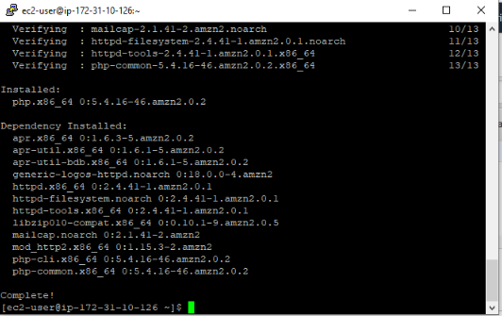

1. Index.php file code

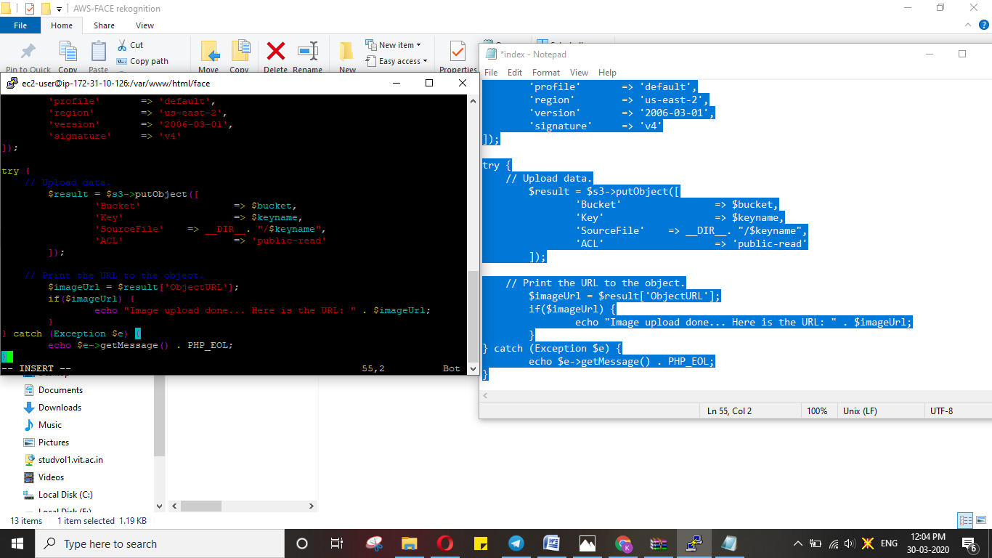

1. Uploading success

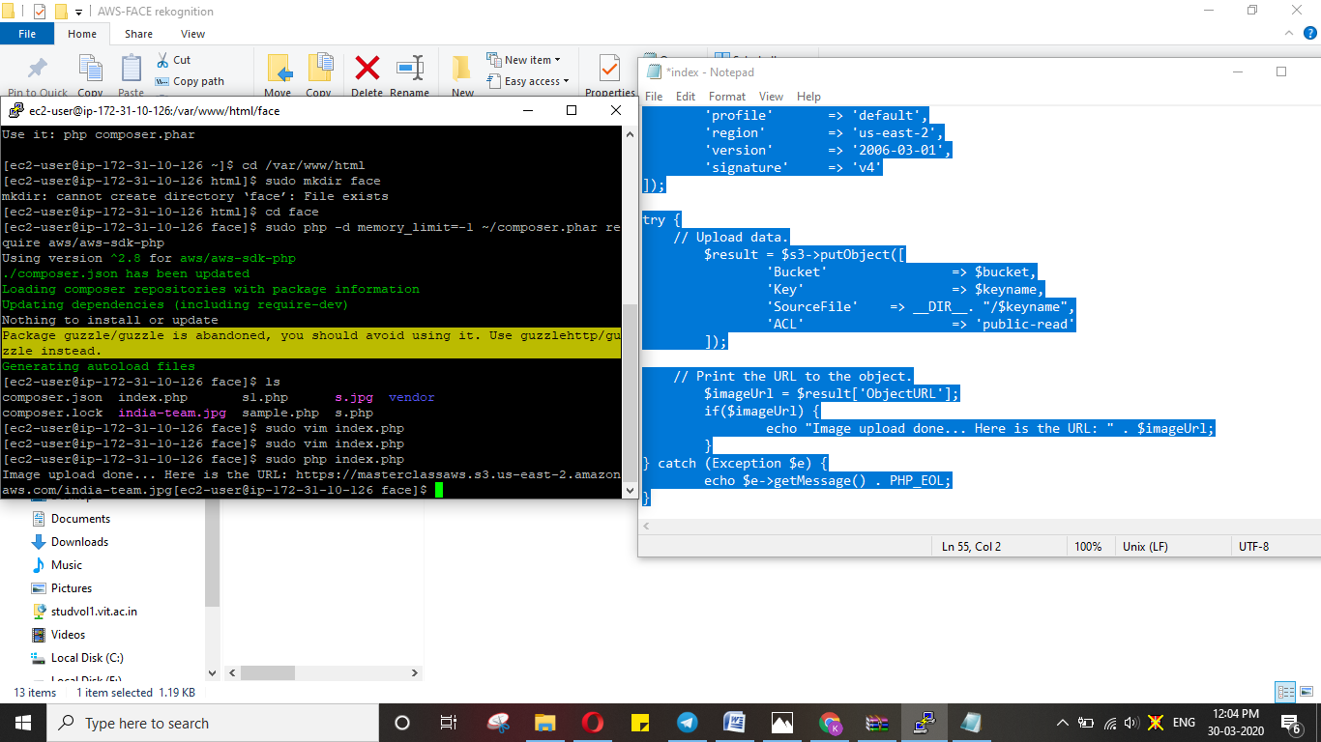

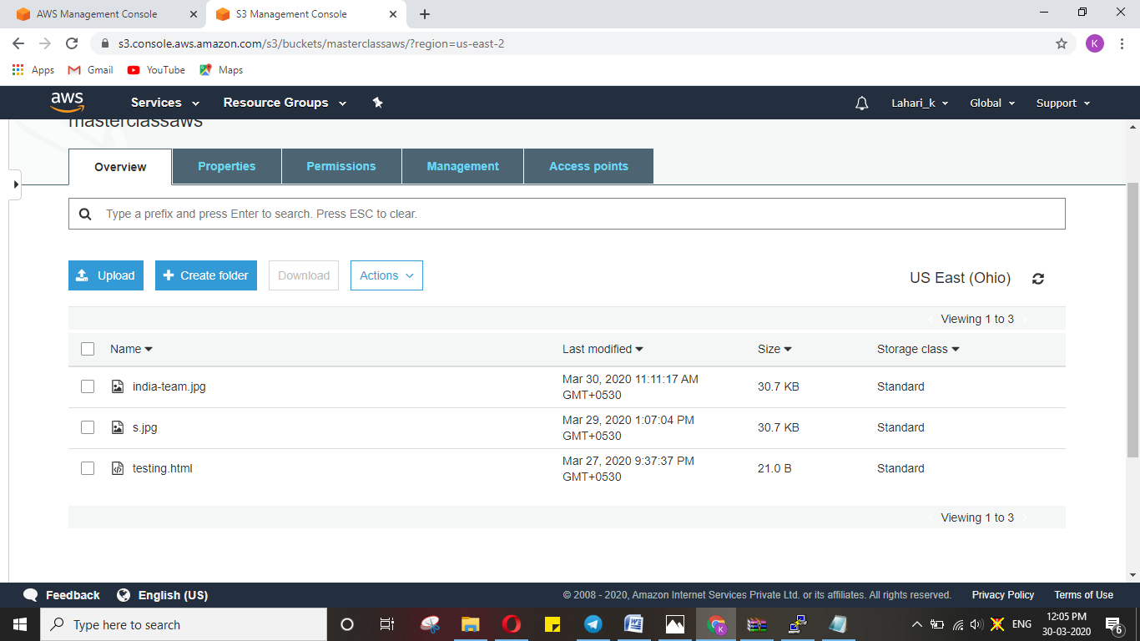

**EC2 – Rekognition**

